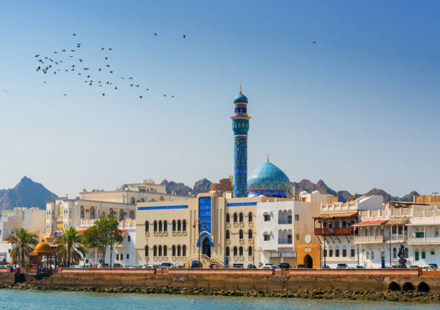

Destination: Oman
Number of pax: 02 Adults
Travel Dates: 29th October 2025 – 04th November 2025
Arrival/Departure Flight: EY 692 (1040) / WY 831 (0900)

Itinerary:

29th Oct/Wed: Arrival in Muscat & City Orientation Tour
- Arrival at Muscat International Airport
- Meet our English-speaking driver & transfer to your hotel. (Early Check in included)
- Afternoon is yours to enjoy at leisure
- Around 1500 hrs, Meet your Spanish/Portuguese speaking guide & start your city orientation of Muscat:
  - Royal Opera House (Inside visit)
  - Al Alam Palace (Photo-stop)
  - Al Mirani & Al Jalali Forts (Photo-stop)
  - Bait Al Zubair Museum (Inside Visit)
  - Muttrah Souk
- Post this drive towards the Muscat Marina.
- Enjoy a 02 hour Omani Dhow cruise at sunset, soaking in the views of the Muttrah Corniche.
Overnight in Radisson Hotel Muscat Panorama or similar

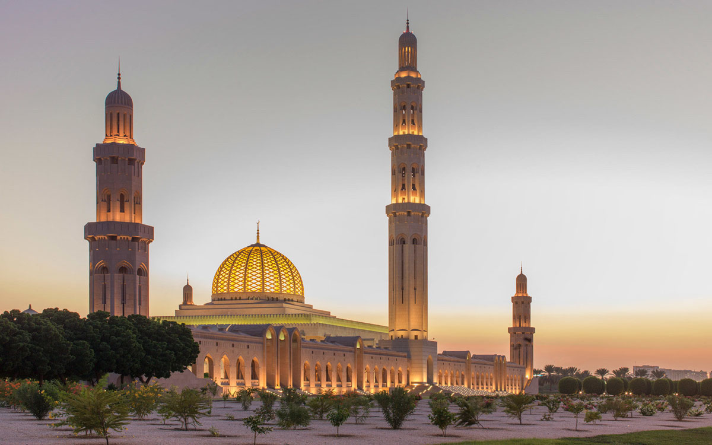

30th Oct/Thurs: Day trip to Barka & Nakhal Forts
- Today, early morning, meet your Portuguese Speaking driver cum guide in the lobby & visit the Sultan Qaboos Grand Mosque.
- Post that, drive towards the city of Barka (Duration: 01 hour)
- Visit the old village of Barkha and its very typical fish market.
- Visit the Nakhal Fort - on its promontory in the middle of date palm plantations.
- Then discovery of the Thawara hot springs and the impressive military fort of Al Hazm and its museum.
- Return to Muscat city by late afternoon, rest of the evening is yours to enjoy at leisure.
Overnight in Radisson Hotel Muscat Panorama or similar

31st Oct/Fri: Drive to Nizwa with en route stops
- Today depart from your hotel along with your Portuguese speaking driver cum guide, drive towards the city of Nizwa. (Duration: 2.5 hours)
- Visit the traditional village of Al Hamra and its Bait Al Safah house-museum, where coffee and dates will be offered to you.
- Continue your drive towards Nizwa, visit the Nizwa Fort.
- Visit the Dates & Halwa Souk.
- Continue your drive towards the Jebel Akhdar Canyons.
- Check into your hotel post the visit.
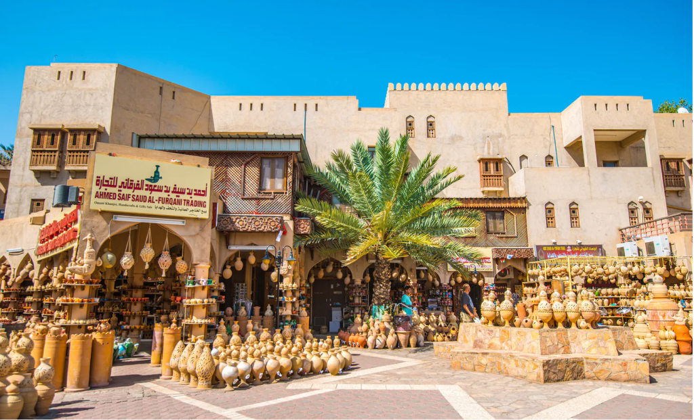

- Rest of the evening is yours to enjoy at leisure.
Overnight in Sama Hotel Jabal Al Akhdar or similar

01st Nov/Sat: Day At Leisure in Jebel Akhdar
- Breakfast in your hotel
- Take this day to enjoy the hotel of stay, offering different activities such as following a butterfly trail via bicycle, Yoga Sessions in the canyon, or just soak in the beautiful mountain air of Jebel Akhdar.
Overnight in Sama Hotel Jabal Al Akhdar or similar

02nd Nov/Sun: Transfer to Wahiba Sands
- Today, drive towards the Wahiba with your Portuguese speaking driver cum guide. (Duration: ~03.5 hours)
- Enroute, visit Al Hamra & the ancient village of Misfat Al Abreeyen – famous for ancient mud houses & cafes.
- Post that, visit Oman Across Ages Musuem on route – newly built museum showcasing the beauty & history of Oman.
- Continue your drive towards Wahiba Sands,.
- Check into your camp/resort after reaching Wahiba Sands.
- Enjoy activities such as camel rides, sandboarding, a movie under the stars, and guided stargazing.
- Enjoy a traditional Bedouin Dinner under the stars.
Overnight in Arabian Oryx Camps
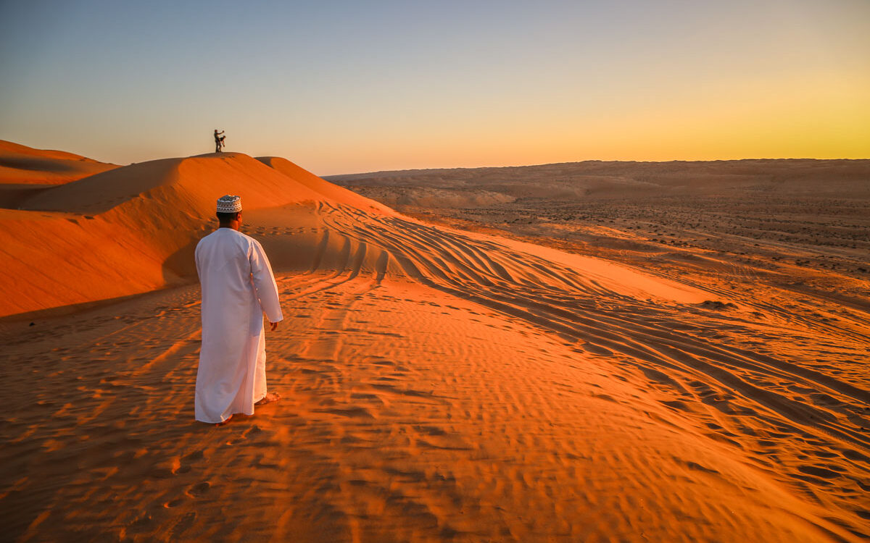

03rd Nov/Mon: Drive towards Muscat & Enjoy a Omani cuisine in Muscat
- Post breakfast today, start your drive towards Muscat (Duration: 3.5 hours)
- Post reaching Muscat, enjoy a traditional Omani Lunch in Bait Al Yasmine along with some local entertainment.
- Drive towards your hotel and check in (Standard check in time: 1500 hrs)
- Rest of the evening is yours to enjoy at leisure.
Overnight in Radisson Hotel Muscat Panorama or similar

04th Nov/Tues: Departure
- Post breakfast today, check out from your hotel.
- Our driver will be waiting in the lobby to transfer you to Oman International Airport as per your flight timings.

End of services

Package Cost & Important Guidelines

Cost: Starting at € 2,040.0 per person (on single occupancy)

Inclusions:
- Accommodation as per below details
- Portuguese Speaking Driver cum Guide from Day 01 to Day 06
- Entrance Fees as mentioned
- Omani Sunset Dhow Cruise (Light refreshments on board) – Seat in Coach basis
- Standard Sedan in Muscat
- 4*4 Land Cruiser from Day 03 to Day 06
- 03 course meal in Bait Al Yasmine (Muscat City)
- Return transfer from Muscat Airport to hotel (with English speaking driver)
- Driver Meals & Accommodation
- Water Bottles on board
- Fuel Cost

Hotel Details:

City | Hotel Name | Room Category | Number of Nights | Meal Plan
Muscat | Radisson Hotel Muscat Panorama | Superior Room | 3 | Breakfast
Jebel Akhdar | Sama Hotel Jabal Al Akhdar | Standard Room | 2 | Breakfast
Wahiba Sands | Arabian Oryx Camps | Superior Single | 1 | Breakfast & Dinner

Exclusions:
- Airfare (Domestic/International)
- Visa Costs
- City Tax – to be paid on ground
- Tips for driver/guide
- Any meals not mentioned
- 5% VAT
- Alcohol
- Upgrade to All Inclusive Meal Plan

Important Guidelines:
- Rooms & Vehicles are subject to availability at the time of booking.
- The above rates are based on 02 people travelling in one land cruiser along with driver cum guide.
- The order of the itinerary may vary, but always keeping all the places to visit.
- Portuguese Speaking Guide is subject to availability.
- Sultan Qaboos Grand Mosque is open from Saturday to Thursday, 0800 hrs to 1100 hrs.
- When visiting the Sultan Qaboos Grand Mosque, visitors must dress modestly, covering arms and legs, and women must also cover their heads & no body hugging clothes.
- In hotels/resorts of Wahiba Sands & Jebel Shams, WiFi & Room service is subject to availability.

